www.bestillwithgod.org.uk

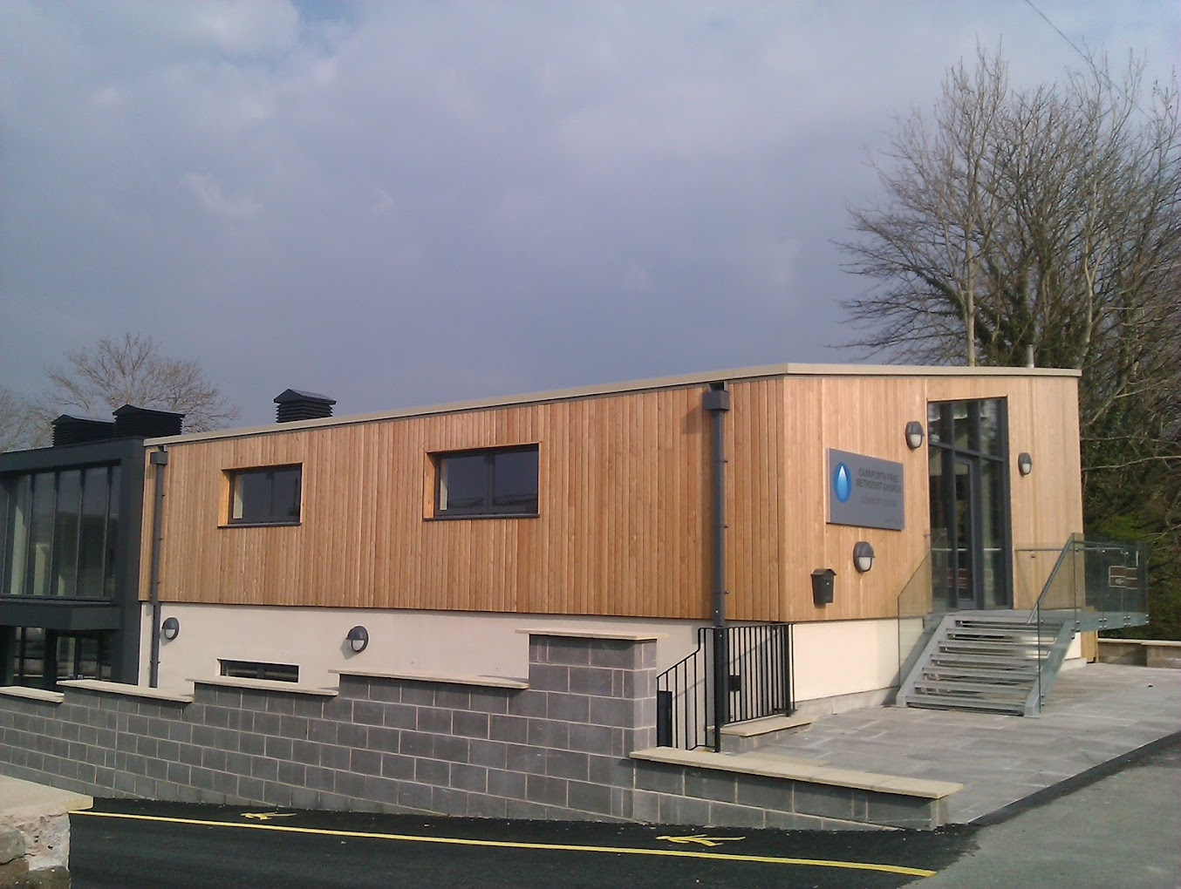

Quiet Days 2025
At Carnforth Free Methodist Church Centre
101, Kellet Rd, Carnforth, LA5 9LR (near Junction 35 off M6)
10am –4pm
Saturday 14th June
&

Saturday 11th October
A time for prayer and reflection whether you have been on a quiet day before or not, come along.

Open to everyone

During the day there will be 2 sessions of teaching and then time to reflect & pray. You may like to bring your own Bible, a notebook & a pen.

Drinks will be provided but bring your own lunch. There will be no charge for the day but a voluntary collection will be
available to cover heating, drinks, etc.

For more information contact Mo Surrey

mo@bestillwithgod.org.uk

for more information on Be Still With God have a look at the website
www.bestillwithgod.org.uk

